3 Easy Steps
1) Fill out application online by tabbing through the fields.
2) Email:
- Save application to your hard drive (File > Save As >)
- File Menu > Send to >Mail Recipient (as attachment)
- To: mfeinstein@frenkel.com
- OR, Fax:
- Save application to your hard drive (File > Save As >)
- Fax To: Hedge Fund Insurance @ 212-488-0432
Any questions please call: 212-488-0270

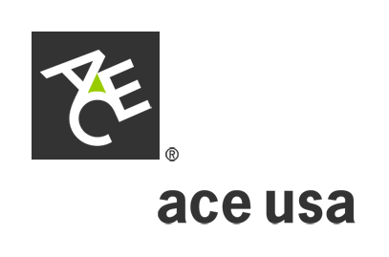
International Advantage®
Corporate Kidnap and
Extortion Application
(Attach additional sheets when necessary)
1. Customer:
2. Home Office Address:

3. Business or type of industry:
4. Financial Information: (Attach latest annual report, if applicable) Total Worldwide Revenue $
5. Employee census information: Total number of Employees (Worldwide):
OVERSEAS TRAVEL INFORMATION
Destination City/Country Number of Employees Frequency/Duration of Trip Reason for Trip

6. Total Number of Permanent Employees stationed/assigned outside the U.S.:
City/Country Number of Employees Number of Directors/Officers Citizenship (U.S. or Other)

7. Describe any previous kidnap, extortion or detention incidents, attempts or threats:

8. Describe any security or prevention measures to protect those persons in Question 5 above from an incident to which this coverage applies:
9. Limit of Insurance requested:
THE UNDERSIGNED AUTHORIZED OFFICER OF THE CORPORATION DECLARES TO THE BEST OF HIS/HER KNOWLEDGE THE STATEMENTS SET FORTH HEREIN ARE TRUE.
SIGNING OF THE APPLICATION DOES NOT BIND THE UNDERSIGNED OR US, BUT IS AGREED THAT THIS FORM SHALL BE THE BASIS OF THE CONTRACT SHOULD A POLICY BE ISSUED.
Signed: Title:
Printed Name: Date:

1901 08-2005

